**WEEKLY PROGRESS REPORT**

**Sightline Capstone Project**

**Week 2**

**19 January 2019**

**Tai:**

**This week:**

* Researched and learned more about Pixhawk 4 and Qgroundcontrol
* Project timelines update
* Answer Q&A question
* Set up an appointment with Greenberg to discuss about the project
* Group meeting

**Next week:**

* Do quadcopter learning
* 1500 OEM test
* Do Pixhawk 4 learning
* Possible start understanding the sample code

**Question:**

There are a few questions I have mentioned in the Q&A which I don’t know how to answer it properly.

**Kimball:**

**This Week:**

* Researched LiPo battery charger, and additional telemetry added to BOM
* Researched Flight modes, Failsafes, and Mavlink
* In depth research of AR0134 dev board Added folder to Github
* In depth research of SLA 1500 FFC IO
* Researched available EAGLE libraries and available footprints

**Next Week:**

* Create need devices, symbols, and footprints for components in EAGLE
* Research safe indoor flight/testing
* Continue research: quadcopter build/ Pixhawk 4 / Q-GroundControl

**Questions:**

In reference to the Sightline schematic of the Airborne Camera FFC connector IO:

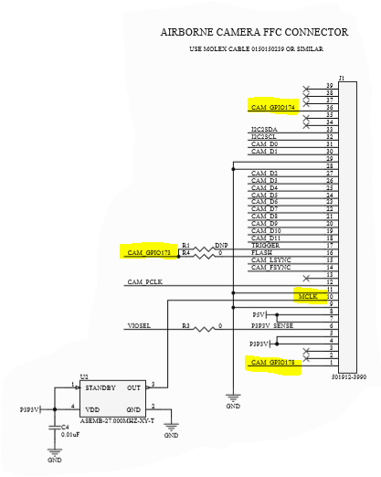

1. What do pins labeled CAM GPIO173, CAM GPIO174, and CAM GPIO178 connect to on the AR0134 sensor?
2. There is a 27 MHz crystal attached to pin 10, MCLOCK (Master Clock?). The AR0134 clock schematic shows a 27 MHz crystal with a jumper for an external clock labeled HB_MCLOCK. Is this where MCLOCK from the FFC connector connects? Is there a reason to have two 27 MHZ crystals if only one is connected through the jumper at a time?

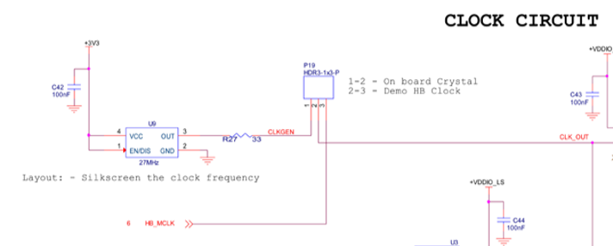

**Adel:**

**This Week:**

**Next Week:**

**Questions:**